
STUDENT CASE STUDY EXECUTION REPORT
Department | CSE
Subject | DSA-2
Academic Year | I-III Semester (2025-26)
Faculty Name | Dr.N.Chaitanya Kumar
Student Name | CH SAI PRASANNA
Roll number | 2520030608
Branch | CSE
Course Outcome | CO-3

Case Study Topic: AgroChain Smart Logistics and Market Optimization using Dijkstra's, Bellman-Ford, Floyd-Warshall, Merge Sort and Quick Sort
Work Done Summary:
In this case study, a Smart Logistics and Market Optimization System was developed for the AgroChain platform. The system optimizes crop transportation routes and organizes agricultural market data using shortest path and sorting algorithms. Dijkstra's, Bellman-Ford, and Floyd-Warshall algorithms were used to determine efficient delivery routes, while Merge Sort and Quick Sort were applied to organize crop demand and market price information.

Implementation Details:
Implemented Dijkstra's Algorithm to determine shortest delivery routes.
Implemented Bellman-Ford Algorithm for weighted transportation networks.
Implemented Floyd-Warshall Algorithm for all-pairs shortest path analysis.
Compared shortest path results across different routing techniques.
Implemented Merge Sort for crop demand ranking.
Implemented Quick Sort for crop price sorting.
Improved logistics planning and market data organization.

Result: Output :
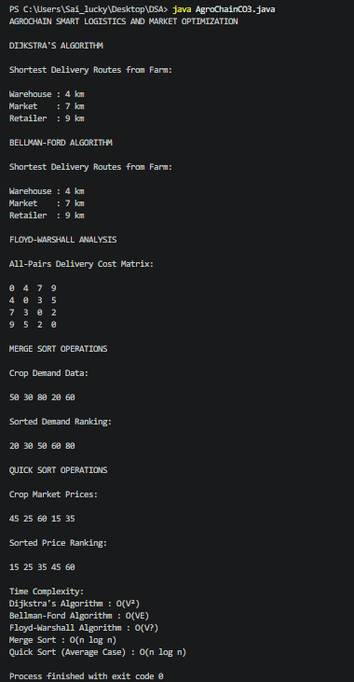
Result:
The AgroChain Smart Logistics and Market Optimization System successfully computed shortest transportation routes and organized agricultural market data using shortest path and sorting algorithms.
Time Complexity:
- Dijkstra's Algorithm : O(V²)
- Bellman-Ford Algorithm : O(VE)
- Floyd-Warshall Algorithm : O(V³)
- Merge Sort : O(n log n)
- Quick Sort (Average Case) : O(n log n)
The implemented algorithms improved route optimization, delivery planning, and efficient organization of crop demand and market price information within the AgroChain platform.

GitHub Link:
https://github.com/PRASANNA18-sai/AgroChain-Smart-Agriculture-Supply-Chain-Management-System

Student Signature | Faculty Signature
________________________ | __________________________

